
FACULTY OF COMMERCE
DEPARTMENT OF INFORMATION SYSTEMS
INF 2007F: APPLYING DATABASE PRINCIPLES
Project Part I
Due Date: 25 April 2025 25th April 2025.

Student Number: ____ NGBBIA002_______
Instructions
- This is an individual assignment.
- The assignment is based on the The African Safari Adventure case study.
- Read the case study carefully and answer the questions that follow after.
- Rename your submission document as follows (ABCXYZ001_INF2007F_ProjectP1)
- All submissions must be made electronically through AMATHUBA by 23h55 on the 25th April 2025.
- Please note that no late submissions will be accepted.
AI usage in this course is governed by UCT’s academic integrity policies and ethical guidelines. Each assignment will specify whether AI use is prohibited, restricted with specific allowances, or fully permitted. Unauthorised AI use that misrepresents personal work constitutes academic misconduct and plagiarism, as outlined in UCT’s Policy for the Prevention and Management of Academic Misconduct by Students. Students are encouraged to review UCT’s guidelines on AI in education, available at the Centre for Innovation in Learning and Teaching (CILT), to ensure responsible and ethical use.

For this assignment, AI Use is prohibited.

Plagiarism and AI Use Declaration:
- I know that plagiarism is wrong. Plagiarism is to use another’s work and pretend that it is one’s own.
- This essay/report/project/……Project…………………… is my own work, and is in my own words (except where I have attributed it to others).
- I have not allowed, and will not allow, anyone to copy my work with the intention of passing it off as his or her own work.
- I acknowledge that copying someone else’s assignment or essay, or part of it, is wrong, and declare that this is my own work.
Signature :_____BA Ngobeni___________________________________
Date: 24/04/2025
Full name:

Your answers goes here:
- Business Rules
- Customer must create an account and become an app user
- Customer must provide their date of birth, name and address
- User must select an option from either Safari Provider, Adventurous Customer, or Performing Group
- Safari providers must provide their LinkedIn Accounts
- Safari providers should offer several safari adventures from the South African National Parks
- Adventures must register their location, address, phone number, website, and available dates
- Safari adventures should offer packages
- Packages should have a name, duration, and price
- Packages should be unique, no matter what
- Adventurous Customers should provide a contact address
- Adventurous Customers must get an ID, tiem and date of booking must be recorded
- Adventurous Customers can request a special type of booking
- If an Adventurous Customer requests a special type of booking, their regular information should be registered and should be able to select the type of entertainment and how long it will last.
- User selecting perfoming group must provide a group name, short bio, and the price per hour
- Every cultural booking should be performed by exactly one performing group
- Perfoming groups can choose the safari provider they want to work for
- For each Safari Provider a perfoming group wants to work with they should indicate their availability by day.
- Entity types:
- User
- SafariProvider
- SafariAdventure
- AdventurousCustomer
- Booking
- CulturalEntertainment
- PerformingGroups
- Package
- NationalPark
Attribute types:
- User(Customer_ID, Name, DateOfBirth, Address, TypeOfUser)
-This information required
- SafariProvider(LinkedInAccount, Safari_Adventure, Package)
- SafarAdventure(Location, Address, PhoneNumber, Website, AvailableDates, Package)
- AdventurousCustomer(BookingID, DateOfBooking, TimeOfBooking, dateOfAdventure, numberOfPeople, Package)
- PerfomingGroups(GroupName, Bio, PricePerHour, SafariProvider)
- Package(PackageName, Duration, Price)
- CulturalEntertainment(Duration, PerformingGroup)
Relationship types:
- Contains
- Includes
- Located in
- Requests
- Makes
- Offers
Weak Entities:
- Safari Adventure is a weak entity with an existence dependency on the Safari Provider
- Package is a weak entity with an existence dependency on Safari Adventure
- Cultural Entertainment is a weak entity with an existence dependency on Adventurous Customers
Key Attributes:
All of these are distinct for each of its own entity it belongs to
- UserID
- BookingID
- PackageID
Composite Attribute types:
These are attributes that can be broken down further into different attributes
- Name
- Address
Multivalued Attribute types:
These are attributes that can have multiple values
- There are no multi-valued attributes for this case study
Data Semantics:
- Specialization:
    - For the superclass and subclass entities: User(Safari Provider, Adventurous Customer, Performing Group), they are all specialised from User
- Constraints:
  - There’s a disjoint constraint from the user subclasses, since a user can only be a Safari Provider, an Adventurous Customer, or a Performing group.
  - There’s an overlap of Safari adventure between the Safari Provider and Adventurous Customer subclasses
- Completeness Constraint:
  - User has a total specialization, as every user must be a Safari Provider, an Adventurous Customer, or a Performing Group.
  - There’s also a partial specialization for Performing Group because it can only belong to a user and none of the subclasses.
2(b) Existence dependencies:
- Safari adventure entity only exists if associated with a Safari Provider.
- Package entity only exists if it’s associated with a Safari Adventure entity.
- Cultural Entertainment entity only exists if it’s associated with a an adventurous customer who selected a special type of booking.
- Perfoming Groups only exist if a customer selected cultural entertainment.

2(c) EER Diagram
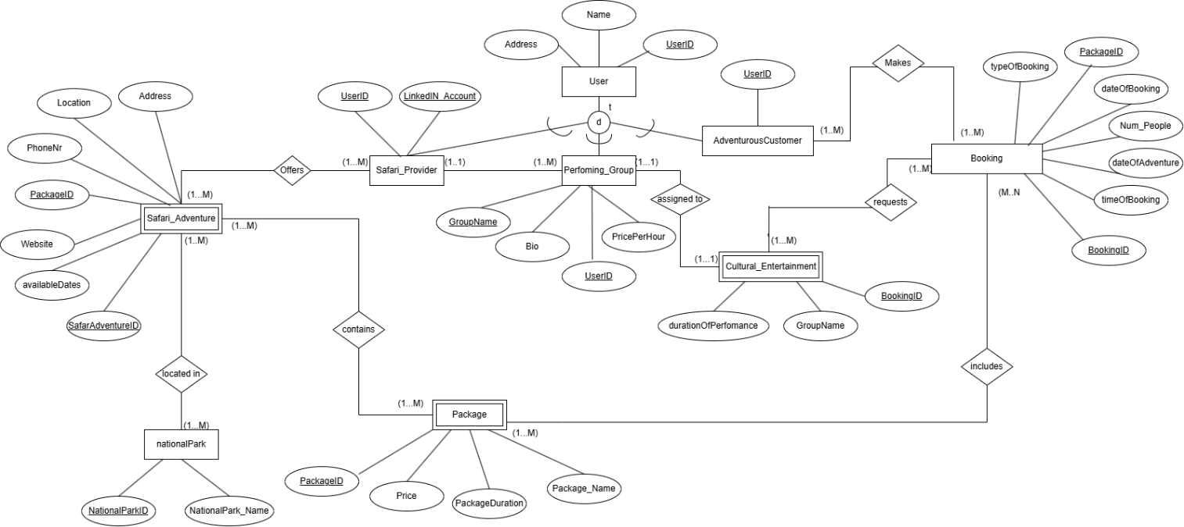

2(d) Semantics not enforced by the EER Diagram
- The diagram does not support domains
- The diagram does not enforce date validations.
- Cannot enforce exclusive participation in the specialized entities
- Cannot enforce package combination restrictions
- Does not validate date comparisons(if a user books a past date or a date where a provider is not available)

- Logical Relation Model
- User(UserID, Name, DateOfBirth, Address)
- SafariProvider(LinkedInAccount,UserID, SafariAdventureID)
- SafariAdventure(SafariAdventureID, Location, Address, PhoneNr, Website, availableDates, Package1D)
- AdventurousCustomer(UserID,BookingID, DateOfBooking, TimeOfBooking, dateOfAdventure, numberOfPeople, PackageID, SafariAdventureID)
- PerfomingGroups(GroupName, Bio, PricePerHour, UserID)
- Package(PackageID, PackageName, Duration, Price)
- CulturalEntertainment(Duration, GroupID)
- Booking(BookingID,DateOfBooking, TimeOfBooking, DateOfAdventure, NumberOfPeople, UserID)

3(a) Relations that are dependent on one another:
- Safari Provider, Adventurous Customer, PerformingGroup relations are dependent on the existence of the user relation.
- Safari Adventure relation’s existence is dependent on the Safari Provider’s relation
- Package relation’s existence is dependent on the Safari Adventure relation
- Cultural Entertainment’s relation is dependent on the Adventurous Customer relation.
3(b) Assumptions and choice of mapping:
- SafariProvider(LinkedInAccount,User_ID Safari_Adventure, Package)
      - User_ID: foreign key refers to User_ID in relation to User. NULL not allowed on delete/update cascade.
- SafariAdventure(Location, Address, PhoneNumber, Website, AvailableDates, Package_1D)
- Package_ID: foreign key refers to Package_ID in relation to Package: NULL not allowed on delete or update cascade.
- AdventurousCustomer(UserID,BookingID, DateOfBooking, TimeOfBooking, dateOfAdventure, numberOfPeople, PackageID, SafariAdventureID)
      - User_ID: foreign key refers to User_ID in relation to User. NULL not allowed on delete/update cascade.
- PerfomingGroups(GroupName, Bio, PricePerHour, UserID)
User_ID: foreign key refers to User_ID in relation to User. NULL NOT ALLOWED
- CulturalEntertainment(Duration, GroupID)

GroupID; Foreign key refers to GroupID, in relation to Performing Groups, NULL NOT ALLOWED

- Booking(BookingID,DateOfBooking, TimeOfBooking, DateOfAdventure, NumberOfPeople, UserID)
Foreign Key refers to Adventurous Customer when booking, null not allowed.

- 1NF:
  - SafariProvider(UserID, LinkedInAccount, SafariAdventureID, Location, Address, PhoneNr, Website, availableDates, PackageID, PackageName, Duration, Price)
  - AdventurousCustomer(UserID, BookingID, DateOfBBooking, TimeofBooking, dateOfAdventure, numberOfPeople,typeOfEntertainment, PerfomanceDuration, GroupName)
  - PerformingGroups(GroupName, Bio, PricePerHour, Duration, availableDay)
Multivalued attributes:
  - Availabledates
Composite Attributes:
  - Name
  - Address

- 2NF:
  - User(UserID, FName, LNameAddress, DateOfBirth)
        - SafariProvider (UserID, LinkedInAccount)
        - SafariAdventure (SafariAdventureID, Location, Address, PhoneNr, Website, AvailableDates, ProviderID)
- Package (PackageID, PackageName, Duration, Price, SafariAdventureID)
- AdventurousCustomer (UserID)
- Booking (BookingID, DateOfBooking, TimeOfBooking, DateOfAdventure, NumberOfPeople, UserID)
- BookingPackage (BookingID, PackageID)
- CulturalEntertainment (BookingID, TypeOfEntertainment, PerformanceDuration, GroupID)
- PerformingGroup (UserID, GroupName, Bio, PricePerHour)
Multivalued attributes:
  - Availabledates
Functional Dependencies:
  - UserID : Name, Address, DateOfBirth

  - SafariAdventureID :Location, Address, PhoneNr, Website, AvailableDates, ProviderID

  - PackageID : PackageName, Duration, Price, SafariAdventureID

  - BookingID :DateOfBooking, TimeOfBooking, DateOfAdventure, NumberOfPeople, UserID

  - BookingID :TypeOfEntertainment, PerformanceDuration, GroupID (CulturalEntertainment)

  - UserID : GroupName, Bio, PricePerHour (PerformingGroup)
Transitive dependencies:
  - GroupName

- 3NF :
- User (UserID, FName, LName, Address, DateOfBirth)
- SafariProvider (UserID, LinkedInAccount)
- SafariAdventure (SafariAdventureID, Location, Address, PhoneNr, Website, AvailableDates, ProviderID)
- Package (PackageID, PackageName, Duration, Price, SafariAdventureID)
- AdventurousCustomer (UserID)
- Booking (BookingID, DateOfBooking, TimeOfBooking, DateOfAdventure, NumberOfPeople, UserID)
- BookingPackage (BookingID, PackageID)
- CulturalEntertainment (BookingID, TypeOfEntertainment, PerformanceDuration, GroupID)
- PerformingGroup (UserID, GroupName, Bio, PricePerHour)
- SafariProviderGroupAvailability (SafariProviderID, GroupID, AvailableDay)
4b.
- Data deletion anomaly can occur when a user deletes something not normalised, for example , if a customer cancels their booking that included cultural entertainment. If the group’s name and performance duration were stored only in that booking row, deleting the booking would also erase the performing group’s details, even though they might still be performing for other providers.
- Insertion anomaly can also occur if a user tries to add new information when another piece is missing, for example, if a new performing group wants to register on the platform, but in the unnormalized table, group details are stored together with booking info. If the group hasn’t been booked yet, there’s no BookingID to attach their details to, so you can't insert them at all
- Update Anomaly, if a user tries to update their information then it may update data stored in only one place, for example, if the price of package increased, and a provider tried to update the price for everyone who booked the package , it is possible that they would only update one area and forget the others.

- I would recommend the Object Relational DBMS because:
- It supports object-oriented features
- It supports complex data
- It can handle specialization and enforce constraints
- It is scalable
- Allows for inheritance which promotes data integrity.
- Its visual representation enforces constraints.
- Manages unstructured data.

- I’d advice him/her to hire:
- A data privacy and compliance officer to ensure that the app complies with data protection laws and to monitor user data handling and also provide data privacy policies
- Data Analyst, too help interpret the data and to support decision making for improving the app
- Database Admnistrator, to ensure data security and to help design and maintain the database
- Data Architect, to design the structure of the database and to esnsure data integrity
- Data Engineer, to help maintain and build systems that move and store the data.

